PFC - Workshop 05

Question 1 (2.5 marks): Write a program to perform these tasks:
- Creating a list in PythonCreate a Class with instance attributes
Write a Python program to create a Vehicle class with max_speed and mileage instance attributes.
Expected Output:
- Create a Vehicle class without any variables and methods
Question 2 (2.5 marks): Write a program to perform these tasks:
- Create a child class Bus that will inherit all of the variables and methods of the Vehicle class
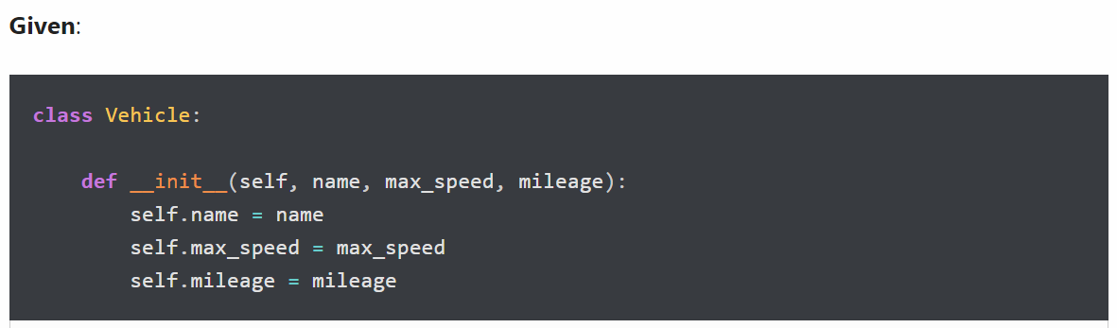
Expected Output:
- Class Inheritance
Create a Bus class that inherits from the Vehicle class. Give the capacity argument of Bus.seating_capacity() a default value of 50.
Use the following code for your parent Vehicle class.
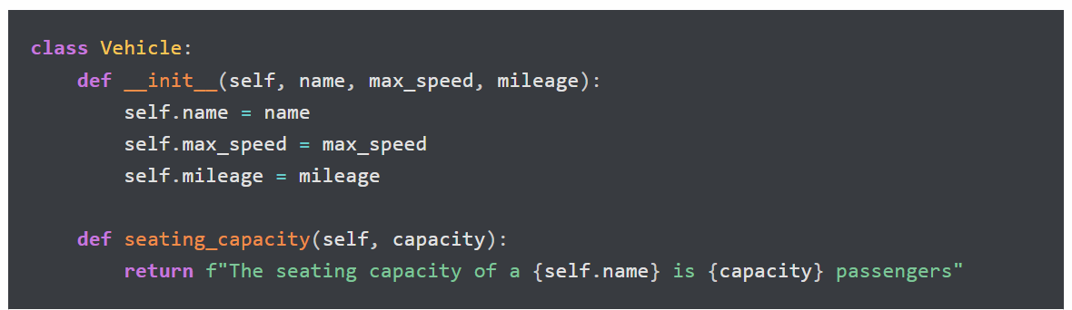
Expected Output:
Question 3 (2.5 marks): Write a program to perform these tasks:
- Define a property that must have the same value for every class instance (object)
Define a class attribute”color” with a default value white. I.e., Every Vehicle should be white.
Use the following code for this exercise.
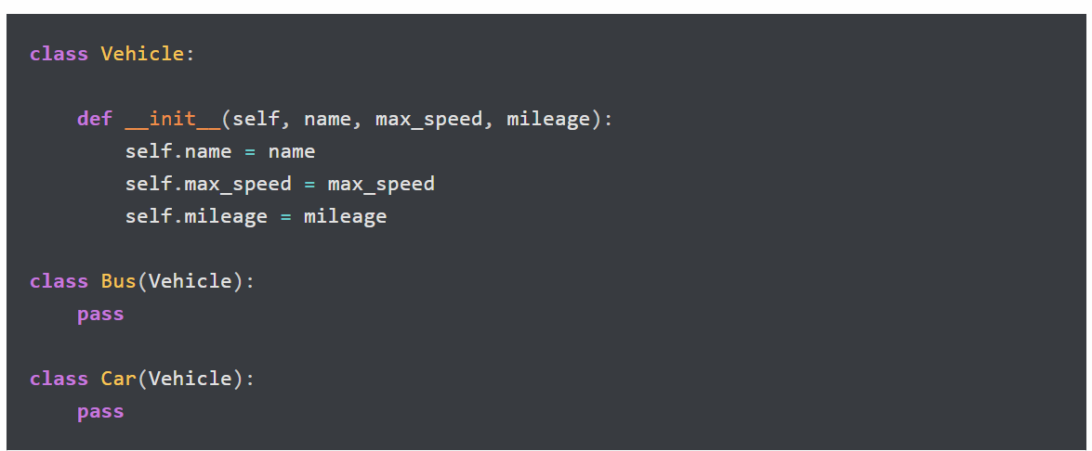
Expected Output:
- Class Inheritance
Given:
Create a Bus child class that inherits from the Vehicle class. The default fare charge of any vehicle is seating capacity * 100. If Vehicle is Bus instance, we need to add an extra 10% on full fare as a maintenance charge. So total fare for bus instance will become the final amount = total fare + 10% of the total fare.
Note: The bus seating capacity is 50. so the final fare amount should be 5500. You need to override the fare() method of a Vehicle class in Bus class.
Use the following code for your parent Vehicle class. We need to access the parent class from inside a child class method.
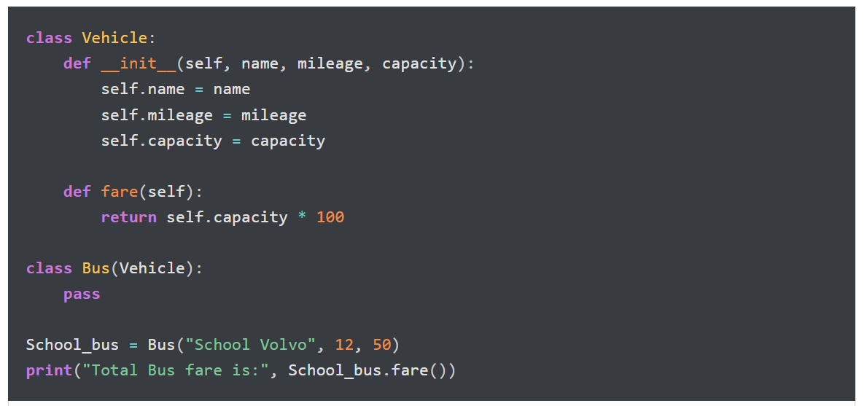
Expected Output:
Question 4 (2.5 marks): Write a program to perform these tasks:

- Check type of an object
Write a program to determine which class a given Bus object belongs to.
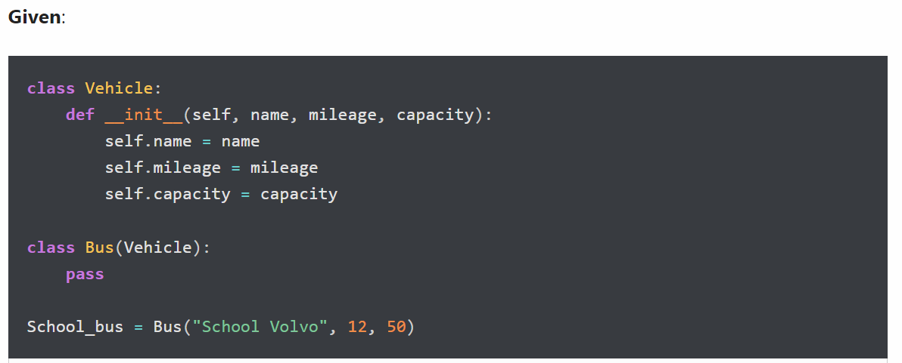
Expected Output
- Determine if School_bus is also an instance of the Vehicle class
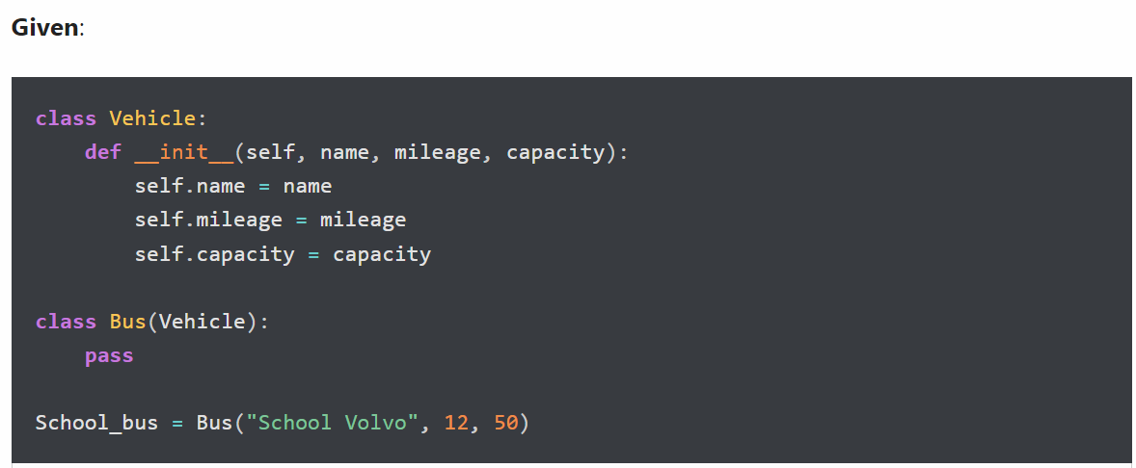
Expected Output:

